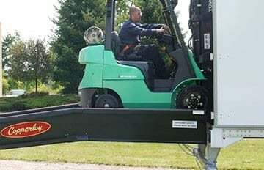
8-FOOT LEVEL OFF
Copperloy mobile ramps have an 8-foot level off feature. This is necessary for forklifts to have easy access onto trucks, loading docks, and platforms. It allows the fork truck to safely enter the trailer at a level approach and without having to stop. This feature makes for a very stable yard ramp and is especially useful on mobile ramps.

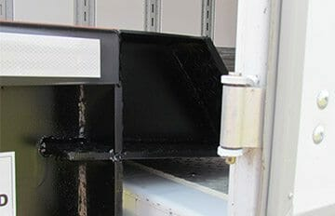
15-INCH LIP
The 15-inch lip is designed to firmly rest on the truck carrier body, dock floor or platform. Our mobile ramps come equipped with eight-foot-long safety chains. Chains join the ramp to keep it from pulling away.

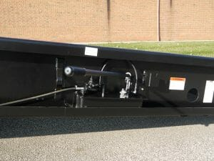
HYDRAULIC PUMP
The single-acting hydraulic hand pump design requires half the effort needed to raise ramp compared to other mobile ramps. The pump is relocated so that it is protected away from dirt, debris, damage and makes maintenance easier to perform. The handle is stored out of the way when not in use.

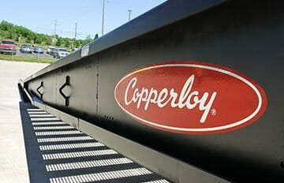
SMOOTH SIDE PLATES
Smooth side plates and safety curbs are standard. They are constructed of high strength steel and enclose all working components, while also protecting them from possible damage from other equipment.
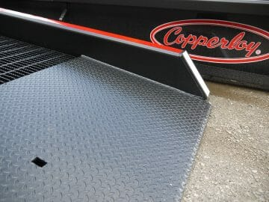
LOW END PLATE
We designed an end plate that is shorter than the wheelbase of most forklift trucks. This way, front-drive wheels can reach high-traction grating, while rear wheels are still on the ground. The plate comes standard with beveling from the underside. This helps to provide an easy and smooth ground-level entry. It also eliminates jolts and bumps as the forklifts travel on and off the yard ramp, with or without a load.
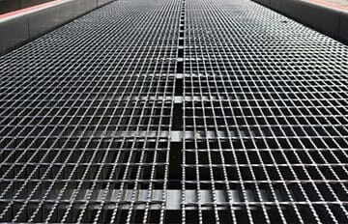
DECK GRATING ON OUR YARD RAMPS
High-strength steel is standard on all Copperloy yard ramps. Grating bars are constructed for durability in the roughest of applications. The 1-3/4 inch bar depth allows snow, rain, and other debris to fall through. The serrated grating helps to ensure an all-weather, high-traction running surface.
SAFETY CURBS
7-inch high curbs are standard on all Copperloy ramps to help prevent accidental runoff with a patented box frame.
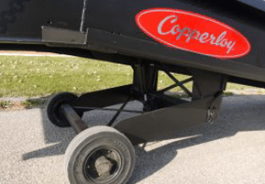
18-INCH SOLID/PNEUMATIC TIRES
The solid/pneumatic tires are standard on all Copperloy mobile yard ramps and are ideal for all applications. The tires do not require air to fill, are maintenance-free, and have lubricated-for-life bearings.
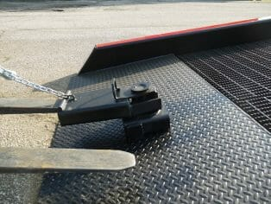
THE YARD RAMP POSITIONING SLEEVE
The position sleeve allows the ramp to maneuver 180 degrees which reduces loading/unloading time and increases productivity. The fork slides into the positioning sleeve and the ramp can easily be positioned into place. The positioning sleeve is included with all steel mobile yard ramps. The sleeve is not intended for long-distance towing.
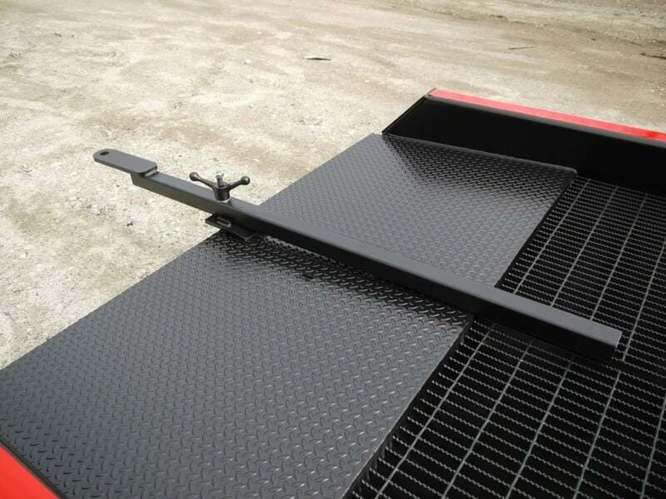
TOWBAR
A towbar is an option on both steel and aluminum mobile yard ramps which attaches to the lower end of the loading ramp. It allows the ramp to be towed a short distance (within your facility). The max towing speed is 5-mph and is not intended for over-the-road towing.

